**Assignment 1**

**Q1:-- Find the time complexity for the following scenarios**

**1) for(i=1;i<=n;i++)**

**{**

**for(j=i;j<=n;j++)**

**{**

**printf(“Hi”);**

**}**

**}**

**Answer:--**

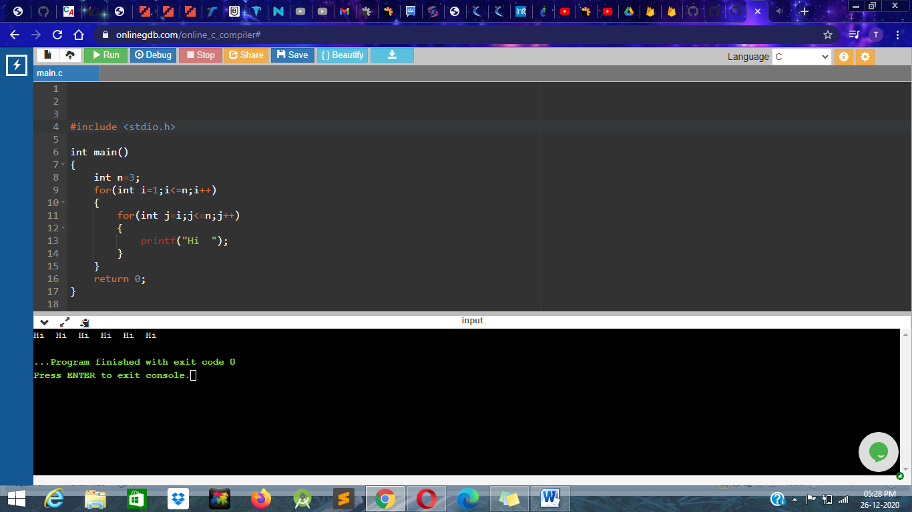

For the following code **“Hi”** printed 6 times it means the **Time complexity** is **Big O(n^2).**

2) **for(i=1;i<=n;i*=3)**

**{**

**for(j=i;j<=n;j++)**

**{**

**printf(“Hello ”);**

**}**

**}**

**Answer:--**

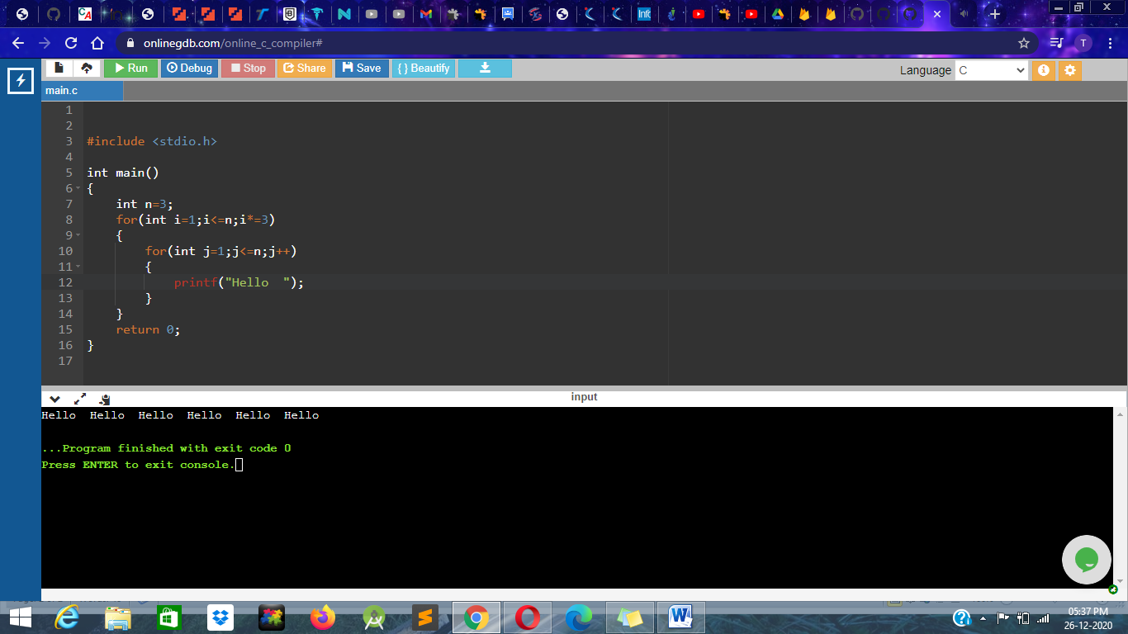

For the following code **“Hello”** printed 6 times it means the **Time complexity** is **Big O(n log n).**